Dear [PRESCRIBER NAME]
I’m [NAME] from [PHARMACY/ORGANIZATION]. I fill prescriptions for some of your patients, and I need your help. To get to the point, compounded hormone patients are facing a threat to their medication — one that is also a threat to my business. It can be stopped, but I need your support to make that happen.
FDA could restrict my patients’ access to compounded hormone therapy, and my ability to provide it to them. I suspect this is an issue you will agree deserves your attention.
In terms of a brief background, an FDA-funded 2020 report from the National Academies of Science, Engineering, and Medicine recommended across-the-board restrictions on compounded hormones – which make a substantive portion of my compounding business. Unfortunately, that report has now been shown to be rife with flaws in methodology and was improperly influenced by FDA.
Even worse, the NASEM report (a FOIA request discovered) was also inappropriately and possibly illegally manipulated by FDA through influence in the committee’s structure, function, and recommendations – manipulations that render the report practically worthless. You can find details of the problems with the NASEM study and an overview of the cBHT threat at compounding.com.
Despite this, FDA has made public statements saying it would base its next steps on compounded hormones on that discredited report – a statement widely interpreted to mean FDA will act to restrict compounded hormone therapy.
Make no mistake: This is not only a clear threat to patients’ well-being, in many cases it’s an existential threat to the compounding pharmacies you work with, including mine.
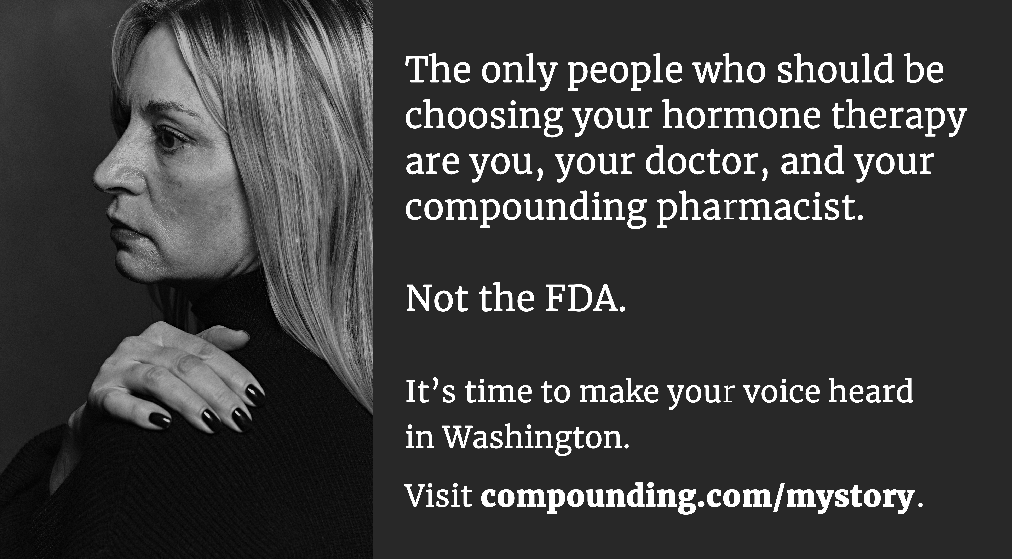
With this in mind, the Alliance for Pharmacy Compounding (the industry trade association for pharmacy compounding) is mounting a $1.5 million communications campaign to engage patients, prescribers, pharmacists, and policymakers in hopes of preventing limitations to the therapies that many patients rely on for their quality of life.
The campaign features the human face of compounded hormones: the millions of patients for whom manufactured hormones are not suited and who benefit daily from compounded hormone therapy.
At compounding.com you’ll find engaged patients sharing their stories, prescribers sharing the threat with their patients, and perhaps most importantly, a tutorial for members of Congress about the benefits of compounded hormones (and this threat to their constituents).
Because compounded hormone therapy is so important to so many of the pharmacies or outsourcing facilities you supply, I believe it’s in your best interest to engage with this effort. How?
- By telling your patients about the threat (I can help provide you materials for doing that!).
- By sharing your own cBHT testimonial and sending a message to Congress at compounding.com.
- By joining APC as a prescriber member and contributing to The Campaign to Save Compounded Hormones. (APC’s sole mission is protecting patient access to life-enhancing compounded medications.)
Time is of the essence. There’s a rumor floating around Washington, DC, that FDA will propose restrictions soon. Please join us in this campaign.
Contact me if I may provide more details or make a presentation.
[signature]

